厦门迪太进出口有限公司
XIAMEN DITAI IMP.& EXP. CO.,LTD
地址：中国厦门禾祥西路鸿升大厦8A
8FL, Hongsheng Building, West Hexiang Road, Xiamen, Fujian, China
TEL:0592-26808108 Phone:+8615160094689 FAX:0592-2680880 E-mail: irene.zhang@xmditai.com
----------------------------------------------------------------------------------------------------------------------
Glycine Tech Grade CAS 56-40-6
Glycine Tech Grade CAS 56-40-6 Product Description
Grade Standard: tech grade
Physical-chemistry property: White crystal powder.sweet taste, esay to bedissolved in water, slightly dissolved in methanol and ethanol,but not dissolved in acetone and ether,melting point:between232-236℃(decomposition).
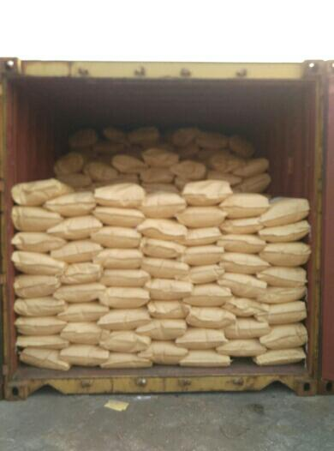

Glycine Tech Grade CAS 56-40-6 Quality Standard:

